**A PROJECT REPORT ON**

**SALARY MANAGEMENT SYSTEM DATABASE PROJECT**

Submitted by

**C S POSHAK [192211760]**

**S MAHABOOB HUSSAIN [192211668]**

**K MAVEEN [192210034]**

*UNDER THE GUIDANCE OF*

**Dr. Carmel Mary Belinda**

(Professor, Department of Applied Machine Learning)

**in partial fulfilment for**

**the completion of course**

**CSA0537-Database Management System for Data Model**



**SIMATS ENGINEERING**

**THANDALAM**

**MAR-2024**

**1**

**BONAFIDE CERTIFICATE**

Certified that this project report titled “**SALARY MANAGEMENT SYSTEM DATABASE**” is the bonafide work **C S POSHAK [192211760], S MAHABOOB HUSSAIN [192211668], K MAVEEN [192210034]** who carried out the project work under my supervision as a batch. Certified further, that to the best of my knowledge the work reported herein does not form any other project report.

Date: Project Supervisor: Head of the Department:

**2**

**TABLE OF CONTENTS:**

|  |  |  |
| --- | --- | --- |
| **S.NO** | **CONTENT** | **PAGE NO** |
| **1.** | ABSTRACT | **4** |
| **2.** | INTRODUCTION | **4-5** |
| **3.** | METHODOLOGY | **6-7** |
| **4.** | LITERATURE SURVEY | **8** |
| **5.** | CODE | **9** |
| **6.** | IMPLEMENTATION | **10** |
| **7.** | TABLES | **11** |
| **8.** | CONCLUSION | **12** |
| **9.** | FUTURE ENHANCEMENT | **12** |
| **10.** | REFERENCES | **13** |

**3**

**SALARY MANAGEMENT SYSTEM DATABASE PROJECT**

**ABSTRACT:**

The aim of the Salary Management System Database Project is to develop an integrated solution for organizations to efficiently manage their payroll processes. Utilizing materials such as database management systems, programming languages, and user interface design frameworks, the project aims to streamline tasks including employee record management, salary calculation, tax compliance, deductions, benefits management, reporting, and analytics. The methods employed involve requirements gathering, system design, database schema development, software implementation, testing, and deployment. Once completed, the system will enable administrators to input and manage employee data effectively, calculate salaries accurately based on predefined structures, compute taxes, manage deductions and benefits, generate reports, and ensure data security. In conclusion, the project aims to provide a robust solution for organizations to enhance their payroll management processes, improving efficiency, accuracy, compliance, and ultimately fostering employee satisfaction and organizational productivity.

**KEYWORDS:** Salary Management, Payroll, Employee, Efficiency, Tax Compliance, Security, Database system, Automation, User Interface, Organizational Productivity.

**INTRODUCTION:**

The Salary Management System Database Project represents a pivotal endeavor in the realm of organizational payroll management. In today's fast-paced and highly regulated business landscape, the efficient handling of salary-related tasks is imperative for sustained success. This project endeavors to tackle the multifaceted challenges inherent in payroll administration by developing a comprehensive database system that integrates various functionalities critical to salary management. By consolidating processes such as employee record maintenance, salary computation, tax compliance, deductions, benefits management, and reporting into a unified platform, the project aims to streamline operations and enhance overall efficiency.

At its core, the project recognizes the growing complexity of payroll systems and the associated risks of manual error and compliance lapses. With the advent of technology and advancements in database management, there exists a prime opportunity to revolutionize traditional payroll practices. By harnessing modern tools and techniques, the Salary Management System Database Project seeks to mitigate these risks and empower organizations with a scalable and robust solution. Moreover, the project emphasizes the importance of accuracy and transparency in salary management, aligning with organizational objectives of fostering trust and satisfaction among employees.

4

Furthermore, the introduction of the project underscores its broader significance beyond mere operational enhancement. Effective payroll management is not only vital for organizational efficiency but also plays a pivotal role in talent retention and compliance adherence. By providing organizations with a sophisticated yet user-friendly system for salary management, the project aims to create a conducive environment for sustained growth and success. Ultimately, the introduction sets the stage for understanding the objectives, scope, and potential impact of the Salary Management System Database Project in transforming payroll practices and driving organizational excellence.

**GANTT CHART:**

|  |  |  |  |  |  |  |  |  |  |  |
| --- | --- | --- | --- | --- | --- | --- | --- | --- | --- | --- |
| **TASK NAME** | **Feb-7** | **Feb-8** | **Feb-9** | **Feb-10** | **Feb-11** | **Feb-12** | **Feb-13** | **Feb-14** | **Feb-15** | **Feb-16** |
| **Planning** |  |  |  |  |  |  |  |  |  |  |
| **Research** |  |  |  |  |  |  |  |  |  |  |
| **Design** |  |  |  |  |  |  |  |  |  |  |
| **Implementation** |  |  |  |  |  |  |  |  |  |  |
| **Follow up** |  |  |  |  |  |  |  |  |  |  |

**5**

**METHODOLOGY:**

The methodology for the Salary Management System Database Project encompasses several key steps aimed at ensuring the successful development and implementation of the system:

**1. Requirement Analysis:**

* The first step involves gathering and analyzing the requirements for the salary management system.
* This includes understanding the needs of the organization, identifying stakeholders, and documenting functional and non-functional requirements.

**2. System Design:**

* Once the requirements are understood, the system design phase begins.
* This involves designing the architecture of the database system, including the structure of the database tables, relationships between tables, and the overall system architecture.
* User interface design is also considered during this phase to ensure usability and accessibility.

**3. Database Implementation:**

* With the system design in place, the database implementation phase involves creating the database schema and implementing it using a suitable database management system (e.g., MySQL, PostgreSQL).
* This includes defining tables, fields, indexes, and constraints according to the system requirements.

**4. Software Development:**

* Concurrently with database implementation, software development takes place to build the application logic and user interfaces of the salary management system.
* This may involve programming languages such as Python, Java, or .NET, depending on the project requirements and preferences**.**

**5. Testing:**

* Throughout the development process, thorough testing is conducted to ensure that the system functions correctly and meets the specified requirements.
* This includes unit testing of individual components, integration testing of system modules, and system testing to validate the overall system functionality.

**6. Deployment:**

* Once the system has been developed and thoroughly tested, it is deployed in the organization’s environment.
* This involves installing the necessary software, configuring the system, and migrating data from existing systems if applicable.

**6**

**7. Training and Documentation:**

* Training sessions are conducted to familiarize users with the functionality of the salary management system.
* Additionally, comprehensive documentation is provided to guide users on how to use the system effectively and troubleshoot common issues.

**8. Maintenance and Support**:

* After deployment, ongoing maintenance and support are provided to address any issues that may arise, implement system updates and enhancements, and ensure the continued smooth operation of the salary management system.

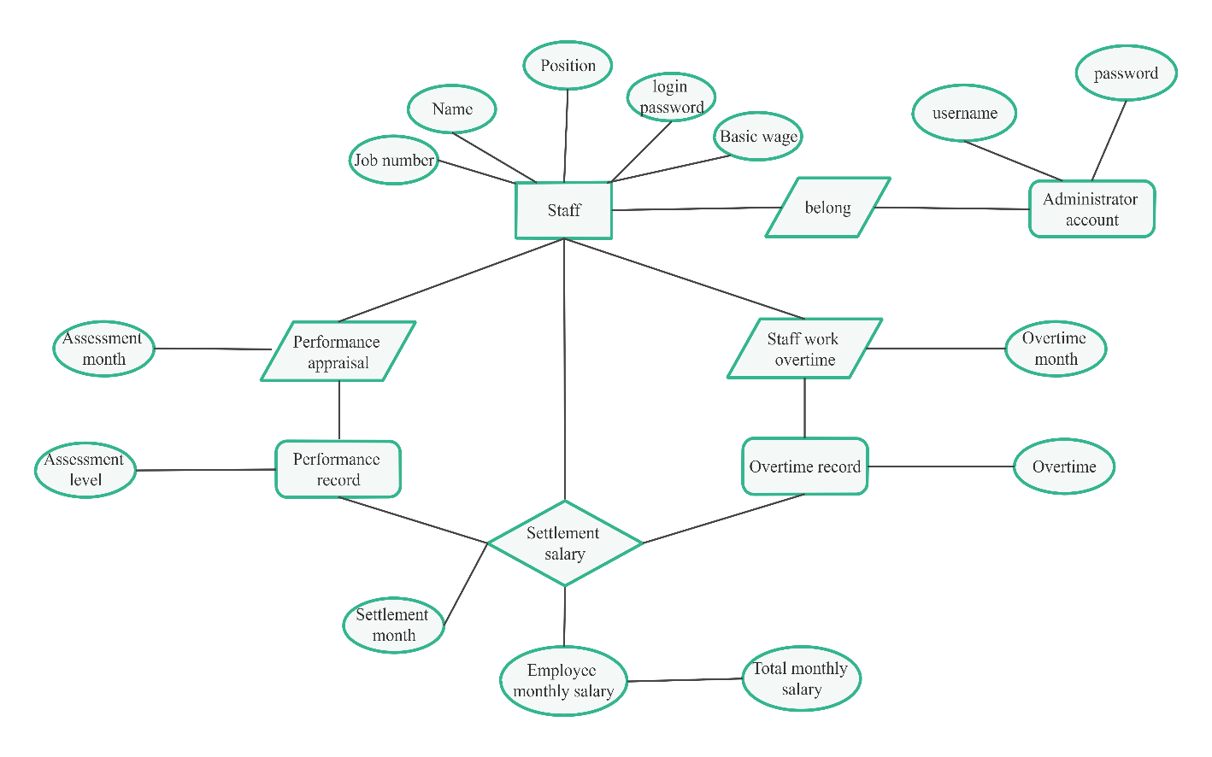

Figure 1. ER-Diagram of Salary management system.

7

**LITERATURE SURVEY:**

* "Design of Human Resource Salary Management System for State-owned Enterprises Based on SSH Architecture," 2021 International Conference on E-Commerce and E-Management (ICECEM), Dalian, China, 2021.
* This paper designs the salary data import algorithm to ensure the validity and safety of the salary data, and completes the design of the state-owned enterprise human resources salary management system.
* “Analysis of the Development and Application of Salary Management System in Railway Enterprise," 2015 International Conference on Computer Science and Applications (CSA), Wuhan, China, 2015.
* This paper hasfully concerned methods of salary management system at home and abroad, combined with China-railway industry characteristics and policy, by making the core rules and logic checking to realizes the automatic calculation and distribution of salary.
* "Research on the Two-Factors Priorities about the Salary System Design of Decision-Makers Based on Cleaner Production Performance," 2009 International Conference on Information Management, Innovation Management and Industrial Engineering, Xi'an, China, 2009.
* This paper has solved the optimization model, we found that comparing with the economic performance evaluation as a priority, the marginal revenue of pollution control is larger and it makes more incentive for decision-makers when environmental performance supervision is firstly considered.
* "The Joint Information Salary Contract Design for Corporate Manager Based on Game Theory," 2010.
* In the research, game model is applied to analyze the relation between the owner and the manager, finding some main factors which affect the manager’s working effort.
* Hao, Zhang, et al. "Salary management system for small and medium-sized enterprises." *Physics Procedia* 24 (2012): 2255-2260.
* The main purpose of writing this paper is to present the basis of salary management system, establish a scientific database, the computer payroll system, using the computer instead of a lot of past manual work in order to reduce duplication of staff labor, it will improve working efficiency.

**8**

**CODE:**

CREATE TABLE departments (

department_id INT AUTO_INCREMENT PRIMARY KEY,

department_name VARCHAR(255)

);

CREATE TABLE employees (

employee_id INT AUTO_INCREMENT PRIMARY KEY,

name VARCHAR(255),

department_id INT,

FOREIGN KEY (department_id) REFERENCES departments(department_id)

);

CREATE TABLE salaries (

salary_id INT AUTO_INCREMENT PRIMARY KEY,

employee_id INT,

salary_amount DECIMAL(10, 2),

salary_date DATE,

FOREIGN KEY (employee_id) REFERENCES employees(employee_id)

);

9

**IMPLEMENTATION:**

**1. Set Up Your Database Environment:**

- Ensure you have access to a MySQL server or a similar relational database management system (RDBMS).

- Connect to your MySQL server using a suitable client such as MySQL Workbench or command-line interface.

**2. Testing and Refinement:**

- Thoroughly test the functionality of your salary management system to ensure it meets the desired requirements.

- Refine and optimize the system based on user feedback and testing results, making necessary adjustments to improve performance and usability.

**3. Execute the SQL Code:**

- Copy the provided SQL code for creating tables (employees, salaries) into your MySQL client.

- Execute the SQL code to create the tables within your database. Ensure that you're connected to the correct database where you want to create these tables.

**4. Verify Table Creation:**

- After executing the SQL code, verify that the tables have been created successfully by checking the database schema.

- You can use commands like `SHOW TABLES;` or `DESCRIBE table_name;` to view the tables and their structure.

**5. Start Populating Data:**

- Once the tables are created, you can start populating them with relevant data.

- For example, you can insert employee details into the employees table and their corresponding salaries into the salaries table.

**6. Implement Business Logic:**

- Depending on your project requirements, you'll need to implement additional business logic such as user authentication, salary calculations, and reporting.

- Write SQL queries or integrate with a backend programming language (e.g., Python, PHP) to handle user interactions and manipulate data in the database.

- You may also need to implement features such as salary adjustments, deductions, and bonuses based on company policies.

10

**TABLES:**

**Employee Table:**

|  |  |  |
| --- | --- | --- |
| Field Name | Data Type | Description |
| Employee ID | Integer | Primary key for identifying employees |
| Name | String | Name of the employee |
| Position | String | Job position of the employee |
| Department | String | Department the employee belongs to |
| Joining Date | Date | Date when the employee joined |
| Contact Info | String | Contact information of the employee |

|  |  |  |
| --- | --- | --- |
| Field Name | Data Type | Description |
| Salary ID | Integer | Primary key for identifying salary records |
|  |  |  |
| Employee ID | Integer | Foreign key referencing Employee Table |
| Salary | Float | Base salary of the employee |
| Payroll Period | String | Period for payroll processing |
| Payroll Date | Date | Date of payroll processing |
| Deductions | Float | Deductions from salary (e.g., taxes, insurance) |
| Net Salary | Float | Net salary after deductions |

### Salary table:

### Department Table:

|  |  |  |
| --- | --- | --- |
| Field Name | Data Type | Description |
| Department ID | Integer | Primary key for identifying departments |
| Department Name | String | Name of the department |
| Manager ID | Integer | Foreign key referencing Employee Table for department manager |

### 11

### 

### CONCLUSION:

### In conclusion, a salary management system is a vital component of organizational infrastructure, offering streamlined payroll processing, accurate compensation management, compliance adherence, and enhanced employee satisfaction. By automating tasks, ensuring data accuracy, and providing valuable insights, such a system contributes significantly to operational efficiency, regulatory compliance, and overall organizational success.

### FUTURE ENHANCEMENT:

Future enhancements for the salary management system could include blockchain integration for security, AI-driven insights for decision-making, and the development of an employee self-service portal and mobile application for accessibility. Additionally, global payroll support, real-time reporting, and integration with HRIS would optimize operations, while benefits management and performance integration would enhance employee satisfaction and retention.

**12**

**REFERENCES:**

### Chadha, Narendra K, 2000, Human Resource Management Issues, Case Studies and Exercise, Shri Sai Printographers, Delhi.

### Chapman, Jeff, 2004, “Employment and Minimum Wage: Evidence from Recent Labour Market Trends”, read online at, http://www.epinet.org/content.cfm/economist#chapman, EPI Briefing Paper #150.

### Desiber, Gary, Human Resource Management, Seventh Edition, Prentice Hall, New Delhi.

### Dwivedi, R.S, 1984, Manpower Management: An Integrated Approach to Personnel Mnagement and Labour Relations, Eastern Economy Edition, Prentice Hall.

* Dai Zongyou, Zhang Wurong, Yang Hui Design Training [M]. Tsinghua
* University Press, 2011:24-25.
* Kensili-hudgins, C# Experience Handbook [M]. Qinghua University Press, 2009:28-29.
* Visual C# 2005 from Beginning to Proficiency, Qinghua University Press, 2009: 33-35
* Zhou Hongan. Learn C# in 21 Days [M] Electronic and Industrial Press, 2009:17-18
* Sai Kuichun, Song Kun, Zhao Zhiyong, etc. C# Information System Development Instance
* Selection [M]. Mechanical Industry Publishing House, 2010:29-30
* Wu Junliang. C# Program Application and Development Courses [M]. Mechanical Industry
* Publishing House, 2010:40-44.
* Lin Qi. Database Programming and Cases. Release Department of China Electric Power
* Press, 2008:53-54
* Kang Xiangshun, Zhang Xiaogang, Liu Liang. C# Program Cases Development Selection
* Publishing House of Electronics Industry, 2008:10-11
* Yuan Pengfei. SQL Server 2000 Database System Management [M]. People’s Pose Press.
* 2008:56-58
* Larsen Microsoft SQL Server 2000 Reporting Services[M]，2009：
* 67～68
* Larsen Microsoft SQL Server 2000 Reporting Services[M]. Tsinghua University Press,
* 2009:67-68
* Matthew Mac Donald .Bedinning ASP.NET 4.0 in C#2010[M].Apress,2010：26～27

### 

### 13